

**Python Basics Assignment**

[support@intellipaat.com](mailto:support@intellipaat.com)

+91-7022374614

US: 1-800-216-8930 (Toll Free)

**Instructions for the Assignment**

1. Use a single file in Jupyter Notebook or Goggle collab for the entire assignment.
2. Download the Assignment file (File> Download > Download as .ipynb), compress it in a Zip folder and submit through LMS only.
3. Submit the Assignment by 30th January 2022 without fail.
4. This Assignment is an Exam kind and is considered for the evaluation and certification. No support is provided by our technical team.
5. If you have any doubts how to work on this assignment (No technical support), please drop an email to [support@intellipaat.com](mailto:support@intellipaat.com)

**FINAL ASSIGNMENT**

1. Using Python script as a calculator for performing the below tasks:

1. Create the variables n, r, p and assign them values 10, 5, and 100 respectively. Then evaluate the following expression in the Python console.

𝐴 = 𝑝 (1 + 𝑟/ 100) 𝑛

1. What are the data types of the variables p, r, n, and A in problem (1(a))?
2. If the data type of the variable ‘n’ is not integer, then redefine ‘n’ as integer with its value being 10 and again compute the value of A.
3. **What will be the output of the following code?**

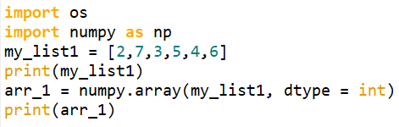

1. Create a string called ‘string’ with the value as “Machine Learning”. Which of the following code(s) is/are appropriate to slice the sub-string “Learn”?
2. Create a sequence of numbers from 15 to 25 and increment by 4. What is the index of the value 19?
3. Which of the following is true with respect to the below codes?

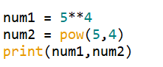

1. num1 = num2
2. num1 ≠ num2
3. num1 < num2
4. num1 > num2
5. We have two lists. L1 = ['Coffee', 'Tea'] L2 = ['Hot', 'Ice']. Using a nested while loop compute the following output:

**Coffee**

**\* Hot**

**\* Ice**

**Tea**

**\* Hot**

**\* Ice**